MIDTERM EXAMINATION
TIME ALLOWED: 60’
Subject: Linear Algebra.
No Book and Laptop allowed

1/ Compute 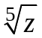, given that 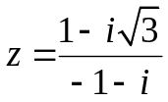.
2/ Find the matrix X such that 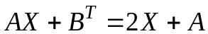, where 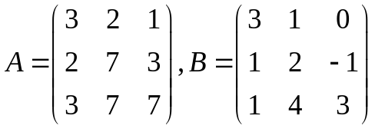.

3/ Determine all real value(s) of m, such that the matrix

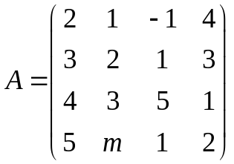 is invertible.
4/ Solve the following system of linear equations
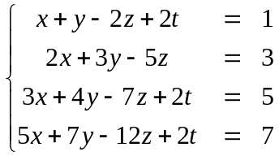

5/ Determine all value(s) of m such that the set is a spanning set for the vector space 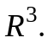

6/ Let 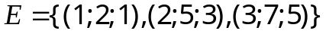 and 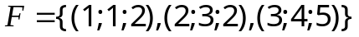 be two bases of 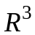. Find coordinates of the vector 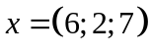 with respect to E , given that 

  

